**Notes on Epics**

An epic is a long, narrative poem that relates the great deeds of a larger-than-life hero who embodies the values of a particular society.

An epic hero undertakes a quest to achieve something of tremendous value to himself and his society.

A kenning is a metaphorical phrase used to replace a concrete noun.

*Examples*

* Sea = Whale’s home or whale’s road
* Battle = Spear play

**Background for *Beowulf***

*Beowulf* is the first great heroic epic written in the English language. It was originally composed in **Old English** around the **11t**h century.

*Beowulf* is set in **Denmark** and **Geatland** (now Southern Sweden). It deals with the Danes and the Geats.

*Beowulf* combines elements of **Paganism** and **Christianity**. It was probably first written down by a **monk**.

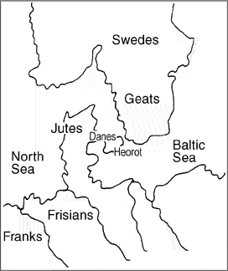

1. Affliction – n. something that causes suffering and pain
2. Infamous – adj. having a bad reputation
3. Lair – n. a wild animal’s resting place
4. Livid – adj. dark bluish gray in color
5. Loathsome – adj. hateful and repulsive
6. Moor – n. broad, open regions with patches of bog
7. Pilgrimage – n. a journey to a historical or religious site
8. Purge- v. to eliminate or wash away
9. Reparation – n. something done to make amends for loss or suffering
10. Spawn – v. given birth to

Open the textbook to page 410.

Hrothgar – King of the Danes

Herot – King Hrothgar’s mead hall

Grendel – monster attacking the Danes

Beowulf – strongest of the Geats and Higlac’s follower

Higlac – King of the Geats; King of Geatland